# Tableau Submission: Responses to questions

## SUMMARY

Tableau story available on: <https://public.tableau.com/profile/nive4608#!/vizhome/FailedprojectsonKickstarter_com_final/Story>

This goal of this project is analyse the nature of failed projects on [Kickstarter.com](kickstarter.com) based on publicly available data from [kaggle.com](https://www.kaggle.com/kemical/kickstarter-projects) for the duration 2008-2016. Kickstarter.com is a hugely popular web site for creative projects, where an individual with an idea for a creative project within any of a number of available diverse categories such as software, food, crochet, photo, DIY etc., may upload details of their work-in-progress project, along with a brief campaign for funding, fulfilment plans, funding goal and deadline. Members of the public who have previously signed up to the site can pledge funding for the promised return and a project is successful if, within the deadline, it reaches its funding goal, and failed if it receives partial or no funding. This visualization aims to shed light on the different aspects of failed projects in those categories which have seen greater than a 50% failure rate, in Tableau story form, looking at their funding profile, trend over time, average backing dollars, and countries where the most failed projects were launched from. Key insights are: digital projects have experienced one of the highest failure rates over all, “Action” projects have seen far more average investment into failed projects than into successful ones, failed projects are on the decline, Japan boasts the highest funding goals for failed projects, and the most ambitious failed project asked for 100 million USD and received no funding at all!

## DESIGN AND ALL FEEDBACK

The base data for this visualization is those Kickstarter project categories that have a greater than 50% failure rate. My overarching design approach is to use a “story” to showcase different visualizations related to these failed projects, and where relevant, seeing these in relation to successful projects, which helps understand failures in relation to successes within the same category. Given the speed and ease of working in Tableau, all sketches and updates were carried out in Tableau itself! The section below is structured to detail each visual, record feedback obtained from 2 people, Person A (senior management consultant) and Person B (HR professional) and show the resulting design iterations.

Visual 1: Project categories where >50% projects failed

To begin with, I sorted the various project categories in descending order of failure rate. A stacked bar graph was the representation of choice here, as it not only gives the viewer the desired failure rate data, but also helps them view this in relation to successful and cancelled projects, as well as see what categories fall below the 50% and 75% thresholds. Visual encoding of the project “status” followed the Tableau color-blind palette, and associated legend to help. Suspended and live projects were excluded. Cancelled projects were excluded in iteration 1, but brought into iteration 2 as these were a non-trivial percentage of the total number of projects.

*Iteration 1 (Initial sketch):*

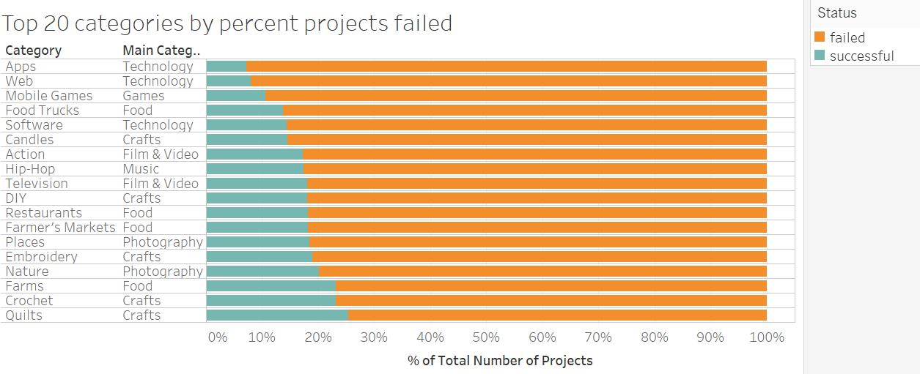

Feedback from person A:

* Given your focus, failed projects should appear before successful projects.
* Main category not needed
* Mark 50% and 75% threshold lines for easier benchmarking
* Call out the insight here.

*Iteration 2 (title captured in story heading):*

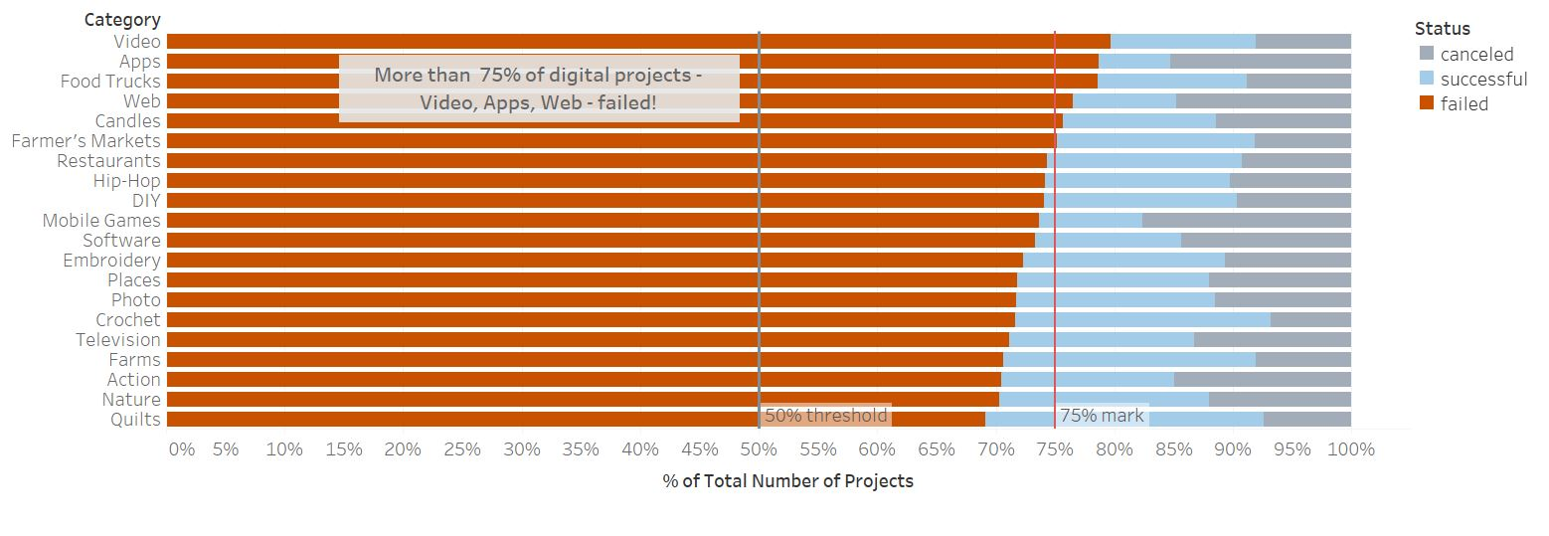

Feedback from person B:

* Retain worksheet title when displayed in story to make the objective of visual absolutely clear. This is in addition to the story narrative.

*Iteration 3:*

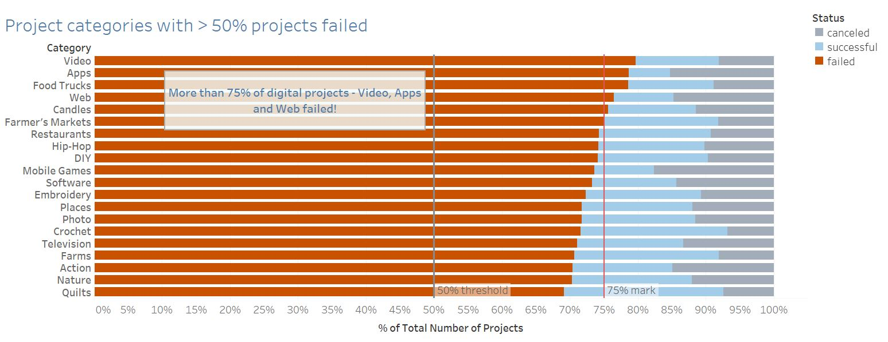

Visual 2: Investment into failed projects

Here, I wanted to show the number of backers and USD pledged for each category from visual 1. Again, a bar graph seemed most appropriate, using a red color encoding to designate failure. I sorted this visual by descending order of USD pledged.

*Iteration 1 (Initial sketch)*:

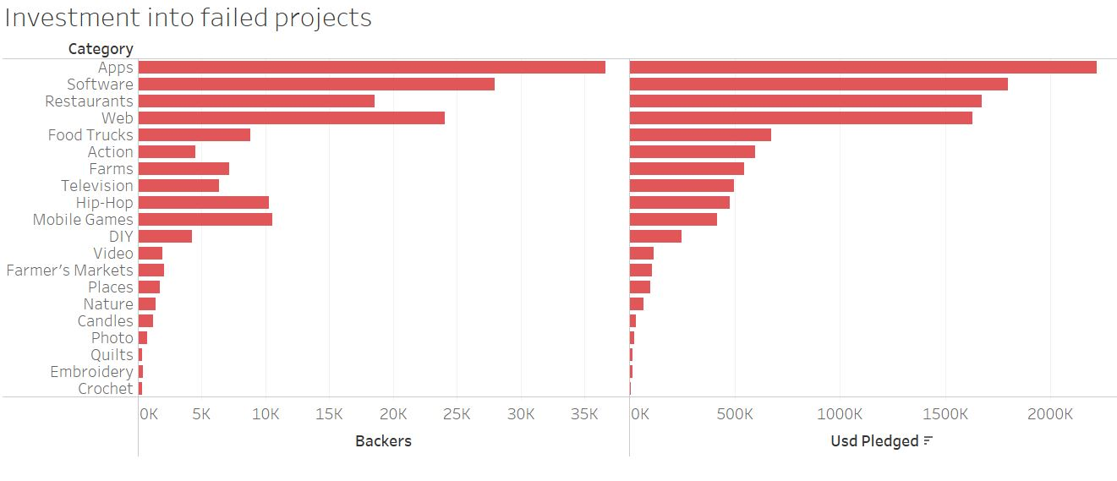

Having looked at this, I thought given the disparate scale of projects in terms of funding goals and backers across categories, it would be wise to “normalize” our view to understand the investment into failed projects in terms of the average dollar pledge per backer.

*Iteration 2*:

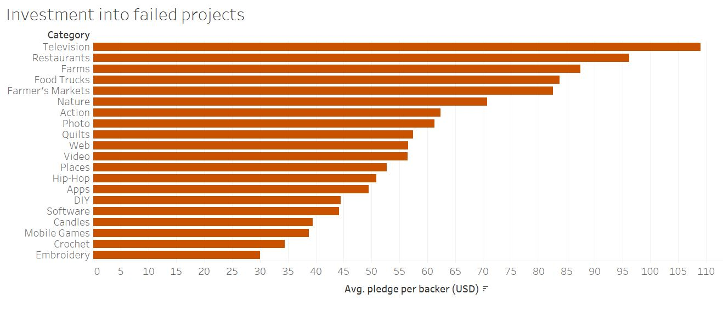

Feedback from person A:

* Compare the average pledge per backer on failed projects to the corresponding figure for projects that succeeded.
* Call out any insight.

*Iteration 3:*

In this iteration, I made the color choices uniform across visuals, using the Tableau color-blind palette, picking a brighter color to represent failure (as this is the focus of our data story), and a lighter color for success. I also removed the sorting in descending order of average pledge per backer, preferring instead for the large bar for failed “Action” projects to stand out for the reader, and calling it out via text.

Such in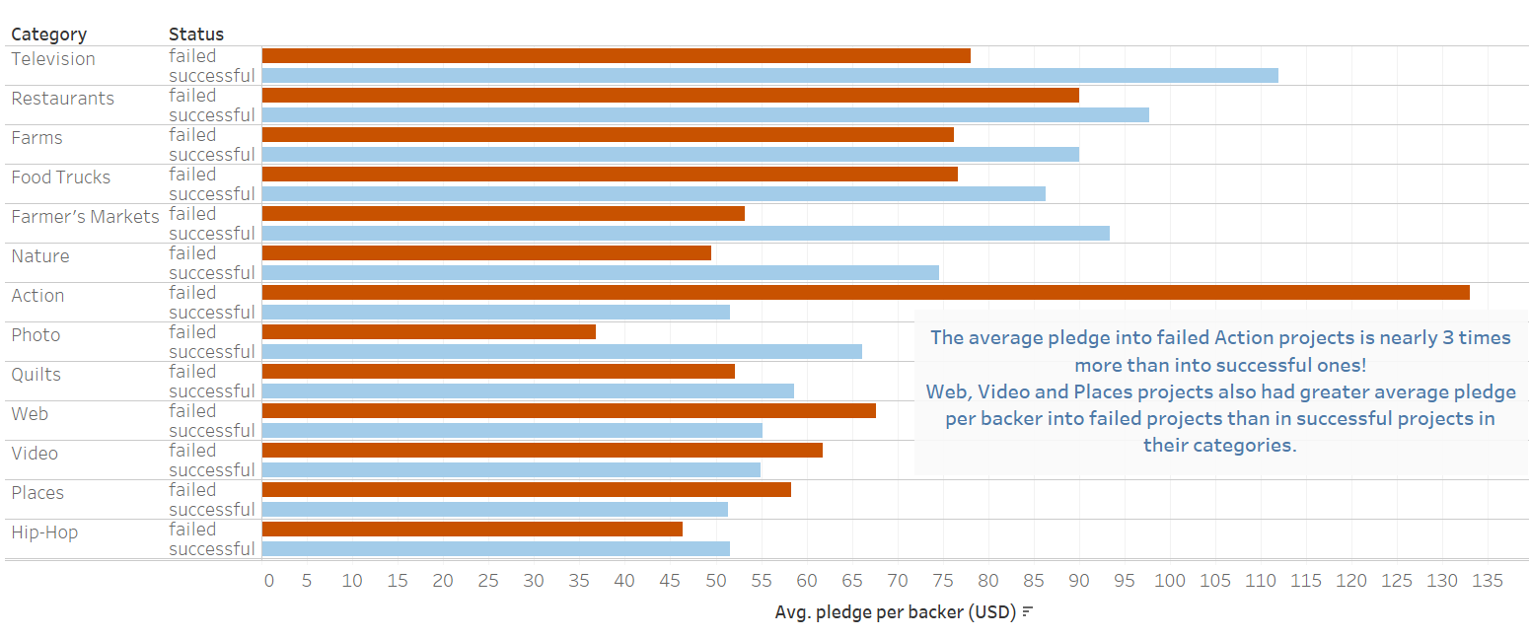

Feedback from person B: Call out single insight into Action projects only.

*Iteration 4:*

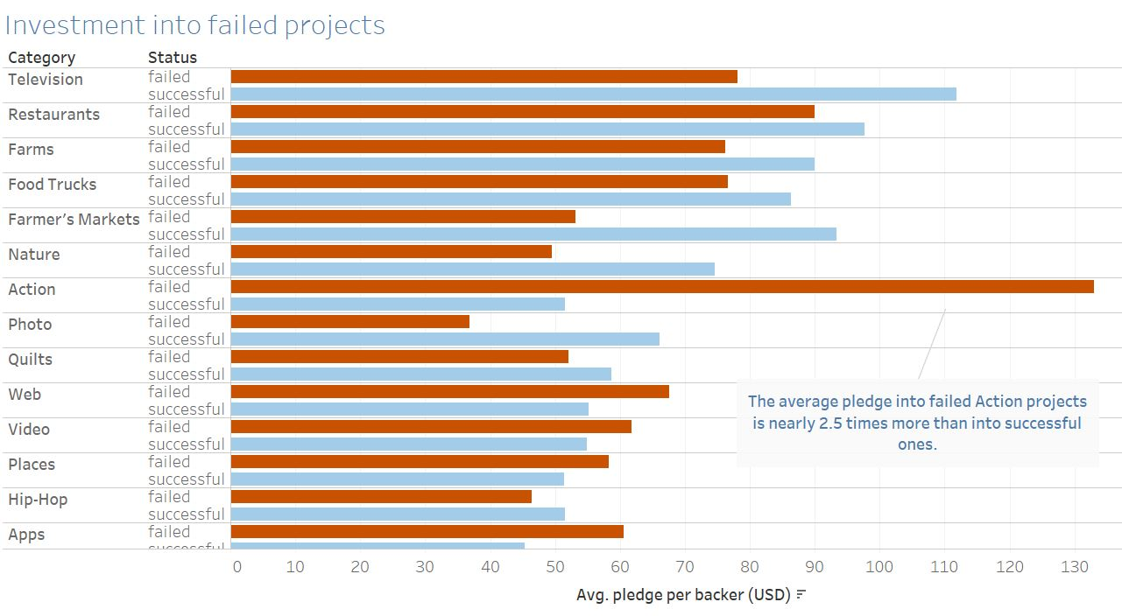

Visual 3: Comparing number of projects failed and succeeded over time

*Iteration 1:*

The next visualization is a time-series graph of the number of failed, successful and cancelled projects based on project launch date. A week-based line graph was chosen here to help the reader see how project numbers have changed over time (for the categories with the highest failure rates), especially *when* the highest failures occurred. For interactivity, I used the “Highlighter” feature in Tableau to enable the reader to highlight different categories, yet retain the overall across-category visualization of the trend in the background. Like the previous viz and for consistency, visual encoding of the project “status” follows the same Tableau colour-blind palette, and associated legend to help.

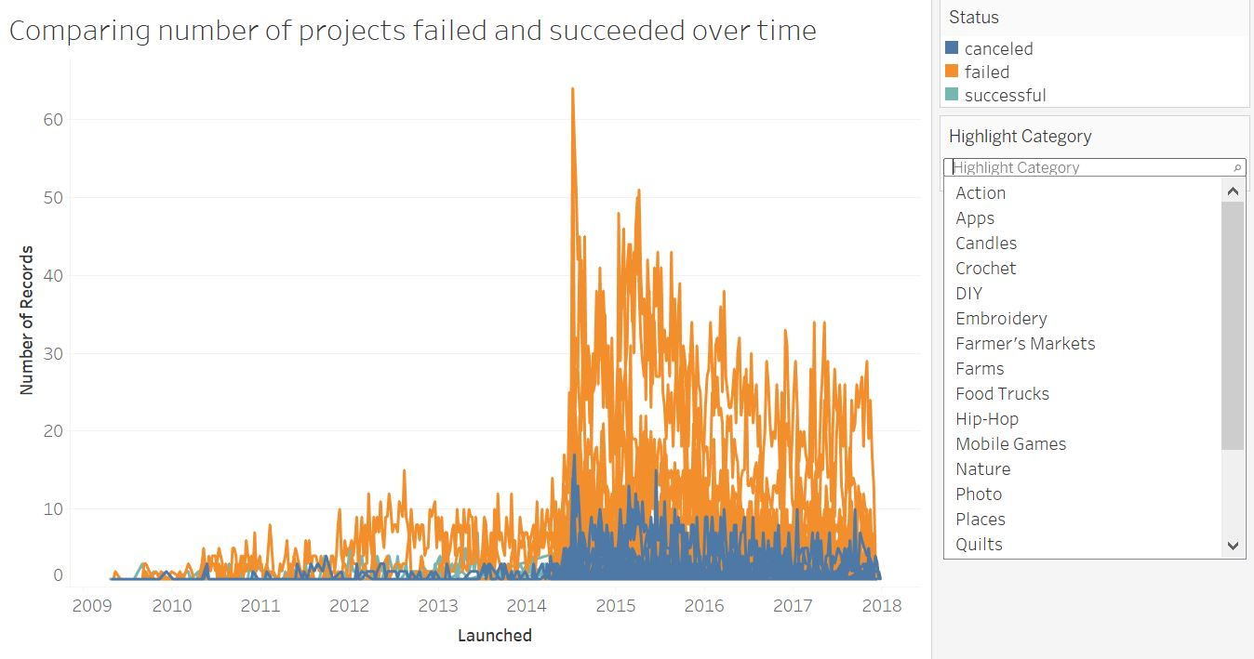

Feedback from person A:

* A week-wise view is too granular and does not add any more useful information to the user than a monthly visual. A monthly view is preferred.
* The highlighter for category is not too intuitive to use. A single-value list is advisable to make it super-easy to use.
* Make a clear comparison of failed projects with successful projects. Cancelled projects can be excluded here.
* It is important for the user to see a trend over time. Call out the insight, e.g. failures are reducing over time, there is a spike around mid-July 2014, 2015.

*Iteration 2* (feedback incorporated and made color selections uniform):

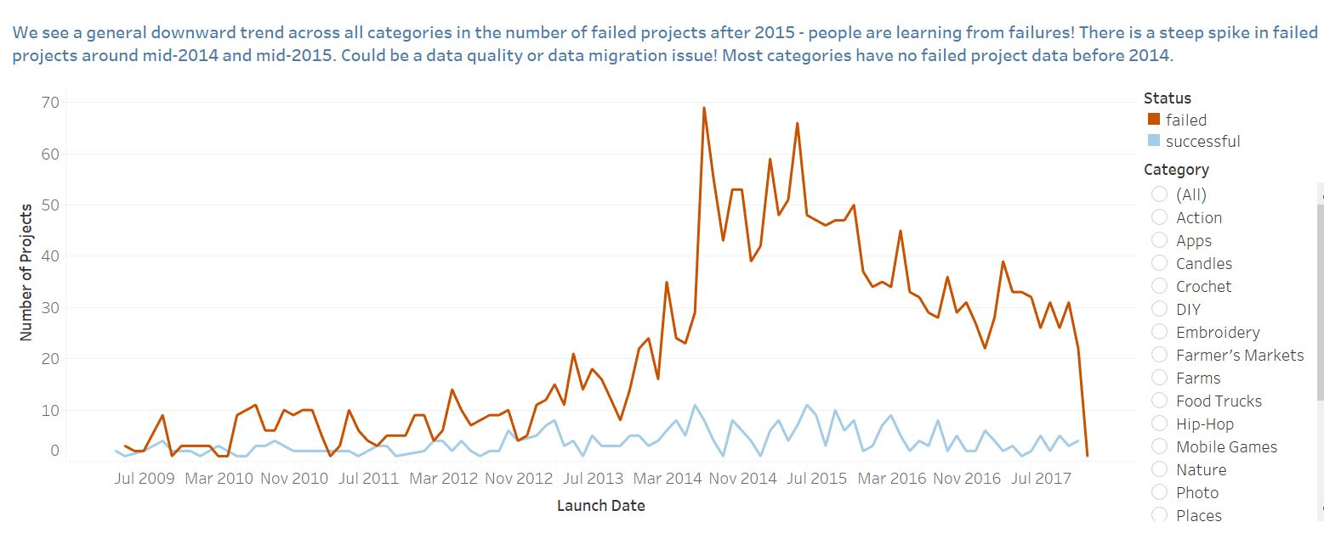

Feedback from person B: None

Visual 4: Funding profile (Funding % by category)

The funding profile viz is designed as a histogram. Here I consider the average percentage levels of funding (pledged/goal) for failed projects in a chosen category, vs. the number of projects, isolating those projects that reached at least 75% of their funding goal. This kind of viz, in future, can not only help pinpoint the categories and projects where this has occurred, but can help focus on the underlying contributing factors for these specific categories.

*Iteration 1:*

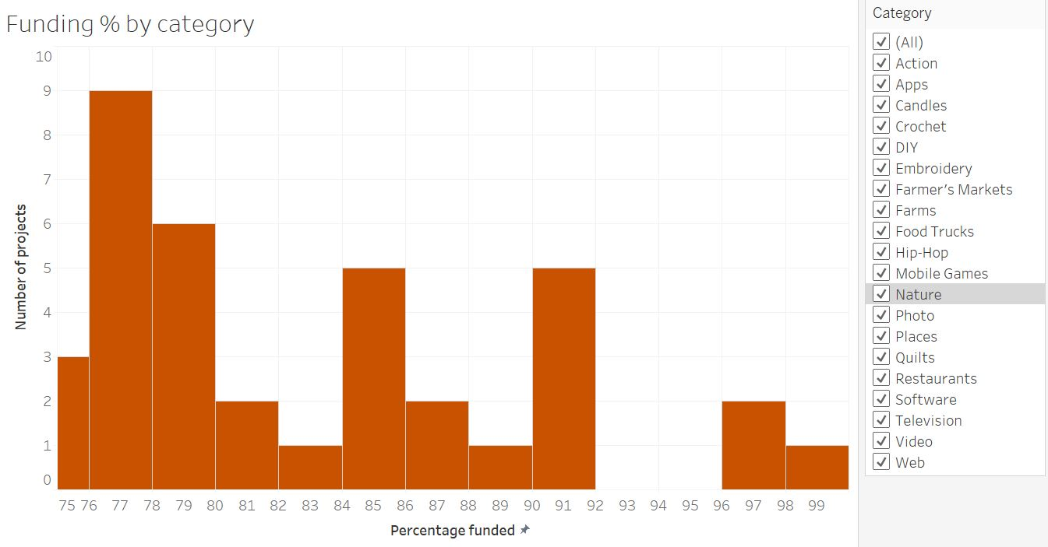

There is a multi-category selector provided to enable the user to view data across single or multiple categories at once. The color selected is consistent with previous visuals.

Feedback from person A:

* Title of the visual is misleading. The focus here is on projects that reached >= 75% of their funding goal.
* Clicking through certain categories does not reveal any data. Narrow the selection to those that actually have projects that fulfil the criteria.
* If there are only a handful of categories that contain any data, color code these into the graph and place a legend on the side. Such a view will enable the user to view all categories at once.
* Call out any insight here.

*Iteration 2* (feedback incorporated):

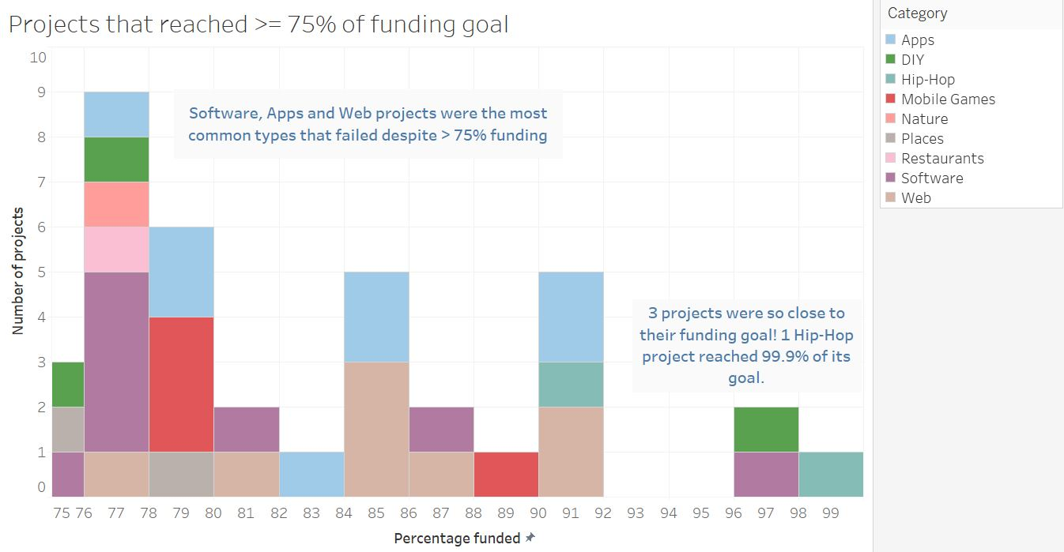

Feedback from person B: None

Visual 5: Country-wise goal vs. funding

The next visualization gives a geographical view of countries where failed projects with the most ambitious funding goals were launched! Here I am interested in showing the funding goal but also how much of the funding goal was realized, i.e. pledged. To do this, I turned the country to into the geographical data type, and marked it on the world map to get an idea of where most projects in the highest-failure categories are launching from. Funding goal was visually encoded as the size of the default mark (circle). Percentage funding was encoded by color intensity. The actual data contained country codes instead of names, so I used Tableau’s “Edit Aliases” feature within the Label marks card to manually translate country codes to names, given the size of this list was not too large.

*Iteration 1:*

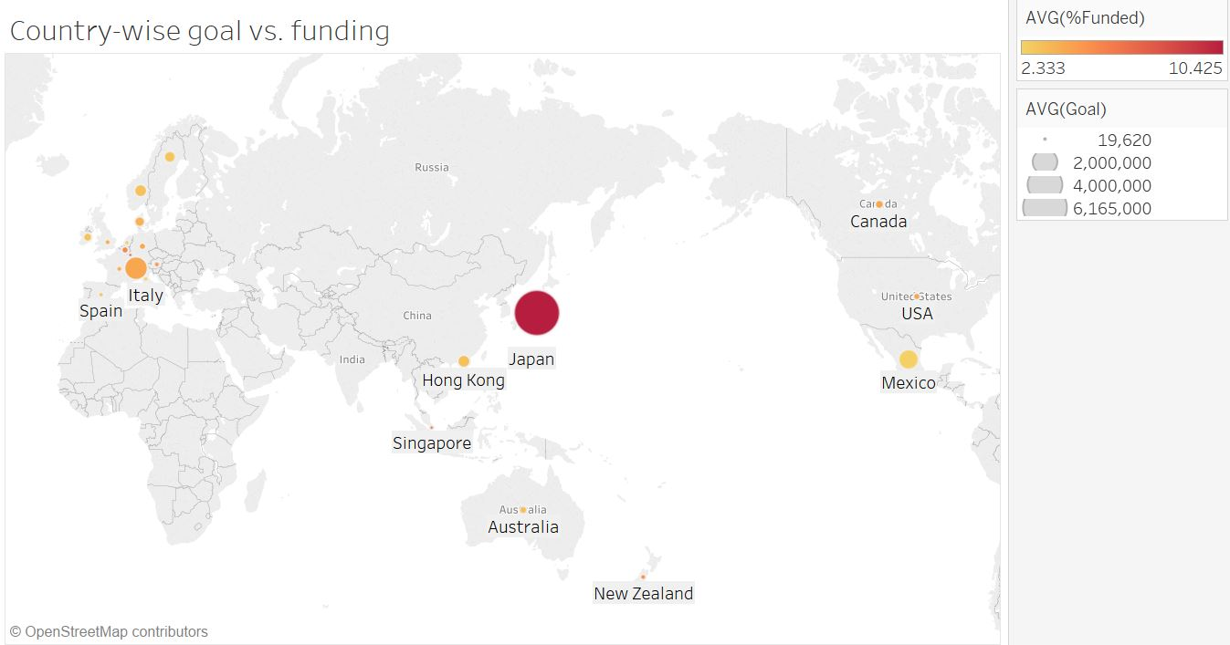

Feedback from person A:

* The color coding should be reversed. So, use darker color for low funding percentages, and lighter ones for higher funding percentages.
* Call out the insight either on the chart itself or the story title.

*Iteration 2 (feedback incorporated):*

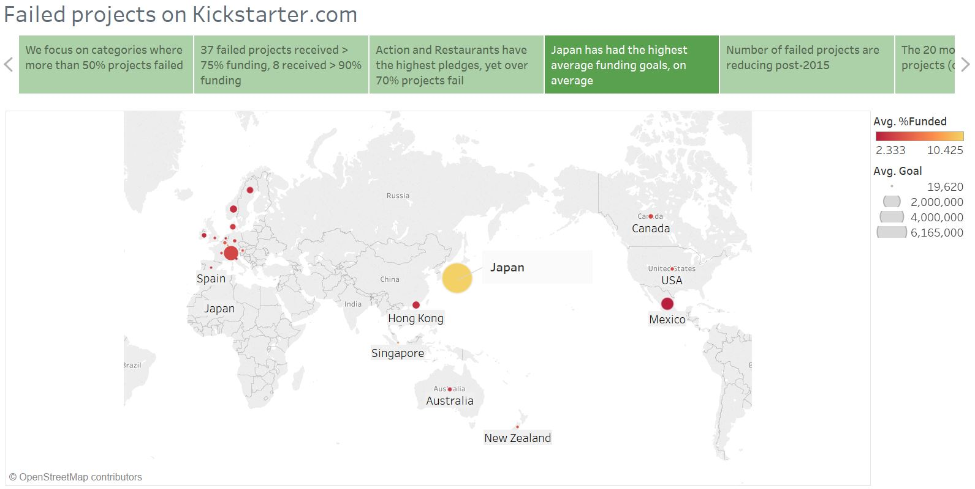

*Iteration 3:*

Having looked at the viz from Iteration 2 above, I decided to break it down by project category. I also felt that %funded did not really add any additional insight here, so decided to simply show funding goals.

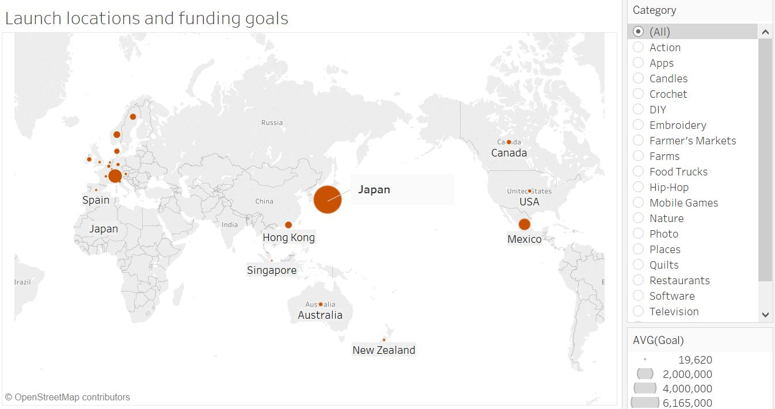

Feedback from Person B: None

Visual 6: Most ambitious failed projects

The next visualization gives a list of the most ambitious failed projects measured in terms of their funding goals. This will help the user drill into the actual project to get a flavor for the kinds of creative projects that come up on Kickstarter.com, how they progress and why they might possibly fail.

*Iteration 1:*

I made a simple table here listing the project names, listing the corresponding project category, and displaying the funding goal as a bar graph. The names are interactive in that the user can click on the name and will be taken to the Kickstarter.com project search page with that project name filled in. From here, they can click in to the actual project. I used the red color to designate failure.

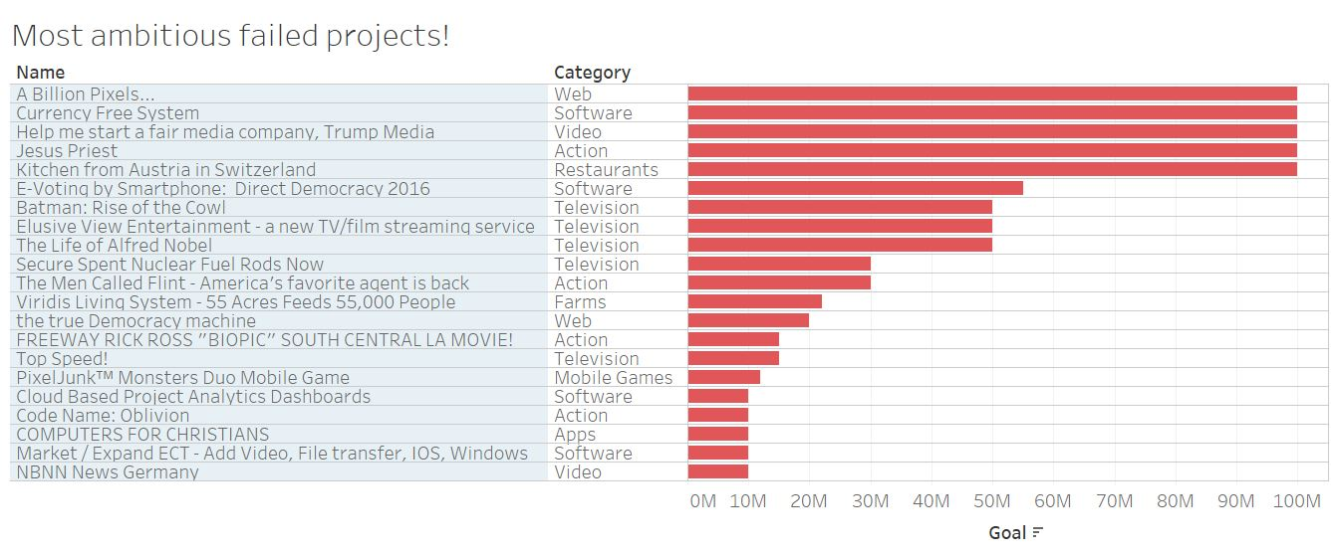

Feedback from person A:

* Underline Project Name to hint to the reader that it is a hyperlink.
* Include the country of launch.
* Be consistent with colors used in other visuals.

*Iteration 2 (feedback incorporated):*

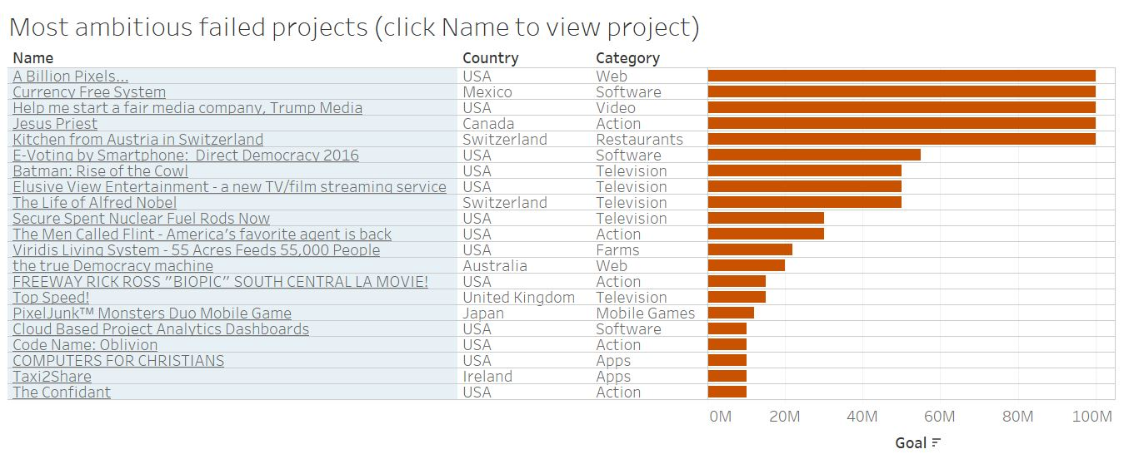

Feedback from person B:

* It would be interesting to know how much was pledged to these failed projects.
* Call out any insight.

*Iteration 3 (feedback incorporated):*

I used a diverging red-green color palette to show how much funding was pledged to these high-profile failed projects and used annotation to call out the insight. See below:

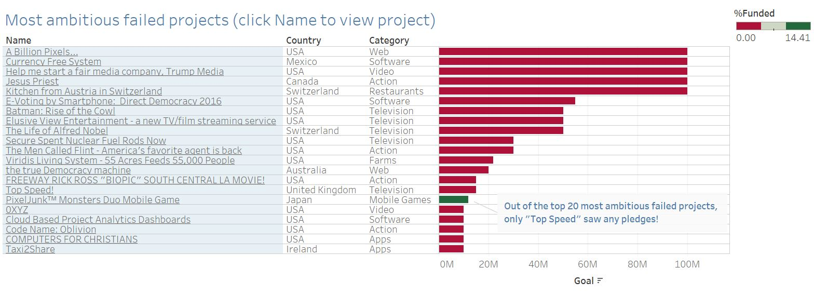

Final visualization: Tableau story

I decided to use a Tableau story to string together the above visuals. The idea here was to showcase different insights considering different aspects of projects that come from high-failure rate categories.

RESOURCES

* <https://www.kickstarter.com>
* Data set and definitions: ks-projects-201801.csv downloaded from <https://www.kaggle.com/kemical/kickstarter-projects/data> on 19th January 2018
* <http://www.dummies.com/programming/big-data/big-data-visualization/how-to-create-table-calculations-and-percentages-in-tableau/>
* <https://community.tableau.com/thread/211892>
* <https://community.tableau.com/thread/150523>
* <https://community.tableau.com/thread/232220>
* <https://onlinehelp.tableau.com/current/pro/desktop/en-us/buildexamples_histogram.html>
* <https://community.tableau.com/thread/232263>
* <http://kb.tableau.com/articles/issue/error-data-extract-required-saving-workbok-to-tableau-public>
* <https://community.tableau.com/thread/203818>